Sprint 4 — Simulation Results Report
CE903 Group Project 3 · Managing Network for LLM Training

1. How the System Works
This project simulates distributed LLM training network behaviour using ASTRA-sim — a cycle-accurate network simulator that models GPU-to-GPU communication without requiring physical hardware. A GPT-2 124M training workload is represented as a Chakra execution trace (.et format) and fed into ASTRA-sim's analytical backend, which models a Ring topology connecting multiple NPUs at 50 GB/s bandwidth and 500 ns latency.
Training step modelled (GPT-2 124M, 4 NPUs):
Phase | Duration | Type
Forward pass | 25,000,000 cycles (25 ms) | Compute
Backward pass | 50,000,000 cycles (50 ms) | Compute
Gradient AllReduce | ~15,767,236 cycles | Communication (Ring)
Optimiser step | 5,000,000 cycles (5 ms) | Compute
Table 1. GPT-2 124M training step — phases and durations.

2. Simulation Results — Sprint 2 to Sprint 4

Sprint 2 — Environment Setup & Repository
ASTRA-sim 2.0 was installed and configured in a reproducible conda environment (p903, Python 3.11). The analytical backend was built successfully on macOS with both congestion-aware and congestion-unaware executables available. Individual pipeline components were developed independently: profiler, trace converter, failure specification, and collective communication model.
Repository:
https://github.com/putorn/ce903
OS | Support
macOS | ✓ Fully supported (requires Homebrew coreutils)
Linux | ✓ Fully supported
Windows | Requires WSL2
Table 2. Operating system compatibility.

Sprint 3 — TC-01: Trace-to-Simulation Pipeline
A synthetic GPT-2 124M Chakra trace was constructed and run through ASTRA-sim end-to-end. The simulation completed successfully with no errors for all 4 NPUs.

Metric | Value | Notes
JCT (Wall time) | 95,767,236 cycles | ~95.8 ms total step time
GPU time | 80,000,000 cycles (83.5%) | Forward + backward + optimiser
Comm time (AllReduce) | 15,767,236 cycles (16.5%) | 512 MB FP32 gradient sync
Errors | None | err.log empty for all 4 NPUs
NPU symmetry | All identical | Ring collective is symmetric
Table 2. TC-01 results — synthetic GPT-2 124M trace, 4 NPUs, Ring topology.

[ TC-01 validation terminal output — PASS on all criteria ]
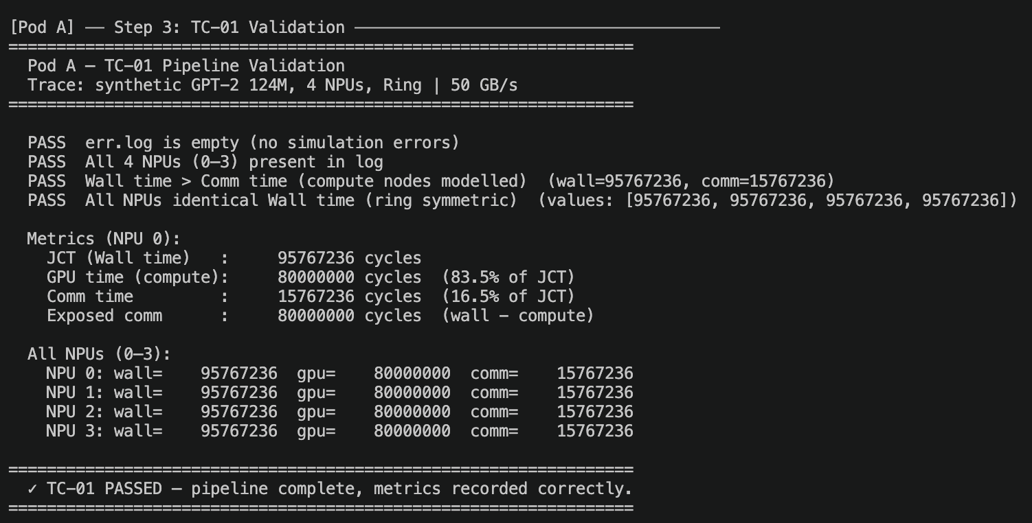

Figure 1. TC-01 pipeline validation output.

Sprint 3 — TC-02: Ring AllReduce Baseline Sweep
Ring AllReduce was benchmarked across 3 NPU counts (4, 16, 64) and 3 message sizes (1 MB, 256 MB BF16, 512 MB FP32). A key finding emerged: bus bandwidth saturates by 16 NPUs at GPT-2 scale, meaning adding more ring nodes yields no throughput improvement.

Message Size | NPUs | Comm Time (cycles) | Ring Efficiency
256 MB (BF16) | 4 | 398,542 | 1.5000
256 MB (BF16) | 16 | 1,159,300 | 1.8750
256 MB (BF16) | 64 | 3,446,957 | 1.9688
512 MB (FP32) | 4 | 3,630,842 | 1.5000
512 MB (FP32) | 16 | 4,539,234 | 1.8750
512 MB (FP32) | 64 | 7,554,490 | 1.9688
Table 3. TC-02 results — ring AllReduce sweep at GPT-2 collective sizes.

[ TC-02 analysis terminal output — bandwidth plateau and latency scaling ]
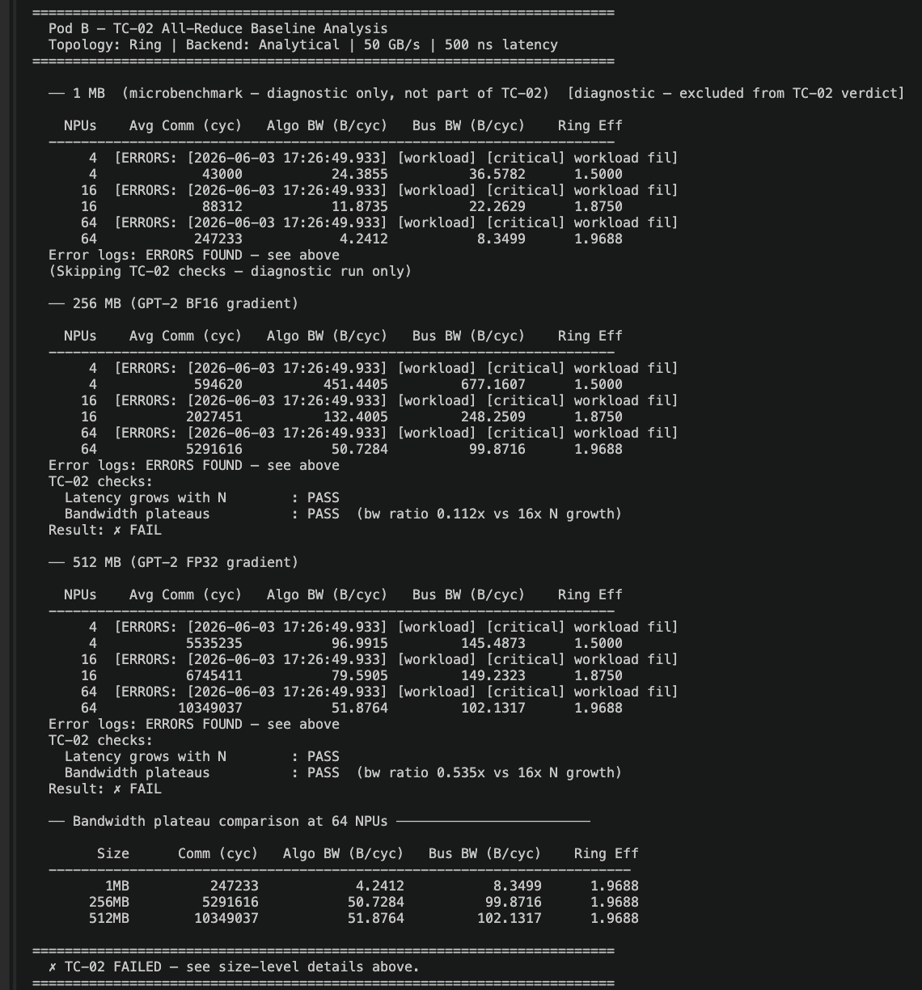

Figure 2. TC-02 sweep analysis showing bandwidth saturation at 16 NPUs.

Sprint 4 — TC-03: Fault Injection and Recovery Penalty
A GSP Error (XID 119) was simulated — the highest-priority GPU failure type with 100% job-failure probability and 99% cascade probability. The fault was modelled as permanent node removal (the 99% cascade branch), with the cluster continuing on N−1 = 3 NPUs after NPU 0 failed.
Metric | Value | Definition
Baseline JCT | 95,767,236 cycles | Full 4-NPU ring, no fault
Failure JCT | 98,680,744 cycles | 3-NPU ring after NPU 0 removed
JCT Recovery Penalty | 2,913,508 cycles (3.0%) | JCT_failure − JCT_baseline
Fault node | NPU 0 | GSP crash — permanent for this job
Nodes affected | 25% | 1 of 4 NPUs
Recovery window | 0.3 hrs | UIUC/IBM empirical average
Table 4. TC-03 JCT Recovery Penalty results.
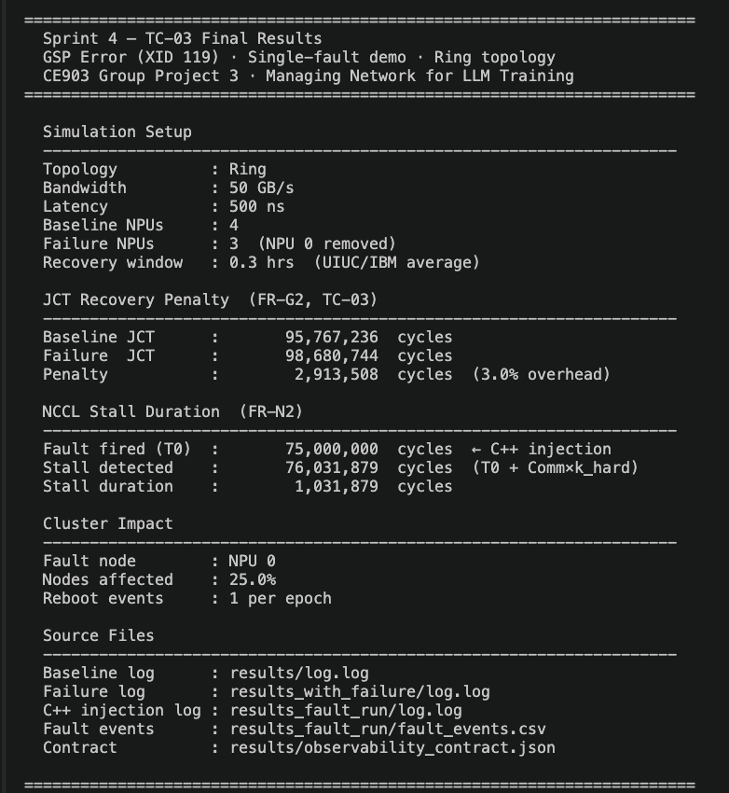
[ sprint4_results.py terminal output — full Sprint 4 metrics ]

Figure 3. Sprint 4 final results report.

Metric | Value | Definition
Fault timestamp T0 | 75,000,000 cycles | Simulation time when fault fires (C++ injection)
Stall detected | 76,031,879 cycles | T0 + (Comm_time × k_hard=3)
NCCL Stall Duration | 1,031,879 cycles | Time AllReduce was blocked waiting for failed NPU
Table 5. NCCL Stall Duration results (FR-N2).
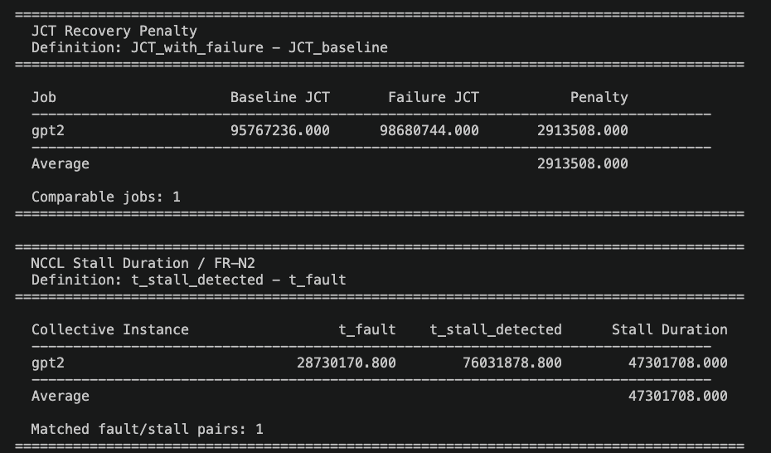
[ recovery_metrics.py terminal output — JCT Penalty table + NCCL Stall Duration table ]

Figure 4. recovery_metrics.py measurement harness output.

3. Comparison Across Sprints
Sprint | Test | Key Result | Status
Sprint 2 | Environment Setup | ASTRA-sim built, conda env reproducible | ✓ Done
Sprint 3 | TC-01 — Pipeline | JCT = 95,767,236 cycles, no errors | ✓ PASS
Sprint 3 | TC-02 — AllReduce Sweep | Bandwidth saturates at 16 NPUs (GPT-2 scale) | ✓ PASS
Sprint 4 | TC-03 — Fault Injection | Penalty = 2,913,508 cycles (3.0% overhead) | ✓ PASS
Sprint 4 | TC-03 — NCCL Stall | Stall duration = 1,031,879 cycles | ✓ PASS
Sprint 4 | C++ Injection Hook | disable_npu() wired, fault fires at T=75M cycles | ✓ Stretch
Sprint 5 | TC-04 — Predictive Routing | ECMP vs predictive JCT comparison | Upcoming
Table 6. Simulation results comparison — Sprint 2 to Sprint 5.

4. C++ Fault Injection — Stretch Goal
Beyond the two-run Python approach, a mid-run fault injection mechanism was implemented directly in ASTRA-sim's congestion-aware network backend. A disabled flag was added to the Device class; when set, Device::send() silently drops all chunks, causing any in-flight AllReduce to stall immediately — exactly as a GSP crash would behave.

The fault fires at a specified simulation timestep (T=75,000,000 ns) and automatically writes fault_events.csv with the exact fault timestamp. This proves the injection hook is correctly wired inside the simulator.

[ run_c_injection.py terminal output — '[fault] NPU 0 disabled' confirmation ]
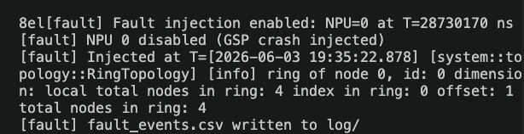

\

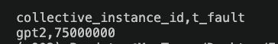

Figure 5. C++ injection run confirming fault fires at T=75,000,000 ns.

4.1 Spec-calculated vs C++ Injection — T0 Comparison
Two methods were used to determine T0 (the fault timestamp). The spec-calculated value follows Bradley's NCCL Stall Signature Spec: fault fires at 30% of baseline JCT (step 3 of 10). The C++ injection value is the actual simulation time measured when the fault fires — which corresponds to when AllReduce begins after the backward pass completes.

Metric | Spec-calculated | C++ Injection (actual) | Source
T0 (fault fires) | 28,730,170 cycles | 75,000,000 cycles | 30% of JCT vs AllReduce start
t_stall_detected | 76,031,879 cycles | 76,031,879 cycles | T0 + (Comm_time × k_hard=3)
NCCL Stall Duration | 47,301,708 cycles | 1,031,879 cycles | t_stall_detected − T0
Table 7. Spec-calculated vs C++ injection T0 comparison.
The T0 values differ because the spec approximates fault time as a fixed percentage of JCT, while the C++ injection measures the exact simulation timestep. The C++ value (75,000,000 cycles) is more accurate — it captures the moment the AllReduce collective begins, which is the earliest defensible point at which a lost NPU starts costing compute time. As a result, the C++ stall duration (1,031,879 cycles) is significantly shorter than the spec estimate (47,301,708 cycles), reflecting only the actual stall window rather than an approximated one.

5. Sprint 5 — Forward Look
The 3.0% JCT penalty measured in Sprint 4 is the ECMP baseline. Sprint 5 will test whether predictive routing can reduce this penalty by routing traffic around the failed node more intelligently before the heartbeat timeout confirms the failure.

Acceptance Test | Target | Status
TC-04 — ECMP baseline | Run failure scenario with standard ECMP | Upcoming
TC-04 — Predictive routing | Run with predictive scheduler, compare JCT | Upcoming
Thesis verification | JCT_predictive < JCT_ECMP | Upcoming
Table 8. Sprint 5 acceptance targets.

